Normalization Process Create 210 Based On 010 | 

Yoel Kortick
Senior Librarian

Create 210 Based On 010

This process task adds the MARC 210 $a to the record and places the Chinese publisher in the 210 based on the ISBN in the MARC 010 $a and a table managed within Alma.

- Go to Resource management configuration menu > Cataloging > Metadata Configuration > CNMARC
- Switch to “Normalization Processes” tab
- Either add a new normalization process or view existing one
- In the “Task List” tab see “Create210BasedOn010
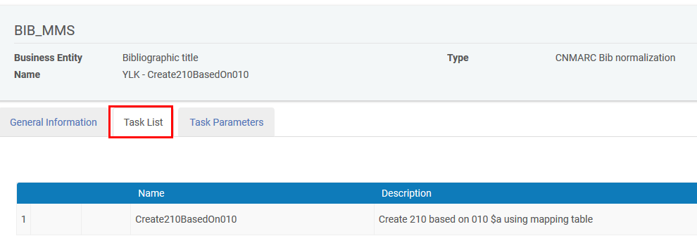
- There are no “Task Parameters” for this process
- See it work as follows:
  - Open a record which has a 010 but does not (yet) have a 210.
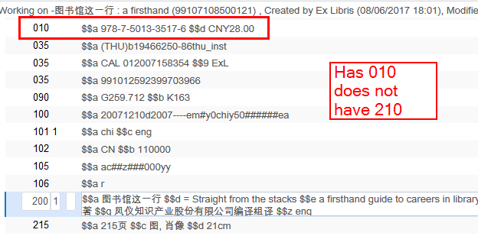
  - Choose Edit record > Enhance Record > Create210BasedOn010
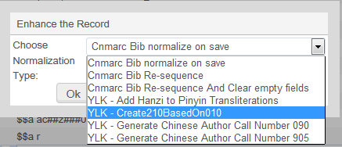
  - See the 210 get created
